🎉 MWCIL Lunch & Learn Social 🎉
Join us for an exciting opportunity to connect, learn, and thrive!
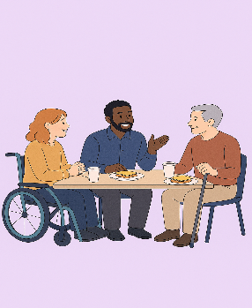
MWCIL’s Lunch & Learn Social is a welcoming space for adults with disabilities to socialize, share experiences, and build skills for Independent Living. Plus, enjoy lunch while meeting new people and learning about your rights!
🗓️ Event Dates for 2026:
12:30 PM – 2:00 PM
- Friday, July 24th
- Friday, August 28th
- Friday, September 25th
📍 Location:
MWCIL
1 Clarks Hill, Suite 200
Framingham, MA 01702

What to Expect:
- Socialize with others
- Learn about your rights
- Develop skills for Independent Living
- Enjoy a delicious lunch!
❗ Important: All events at MWCIL are scent-free for the comfort of everyone.
📝 Who Can Attend:
Open to anyone currently working with an MWCIL Coordinator.

For More Information:
📞 Call: (508) 875-7853
📧 Email: dcarr@mwcil.org

We Look Forward to Seeing You There!

